Github: Shahidhasib586
Linkedin: Shahid Ahamed Hasib
First clone the foloowing github repository to your ros2 workspace:
https://github.com/ShahidHasib586/bluerov_ws
Connecting your BlueROV:

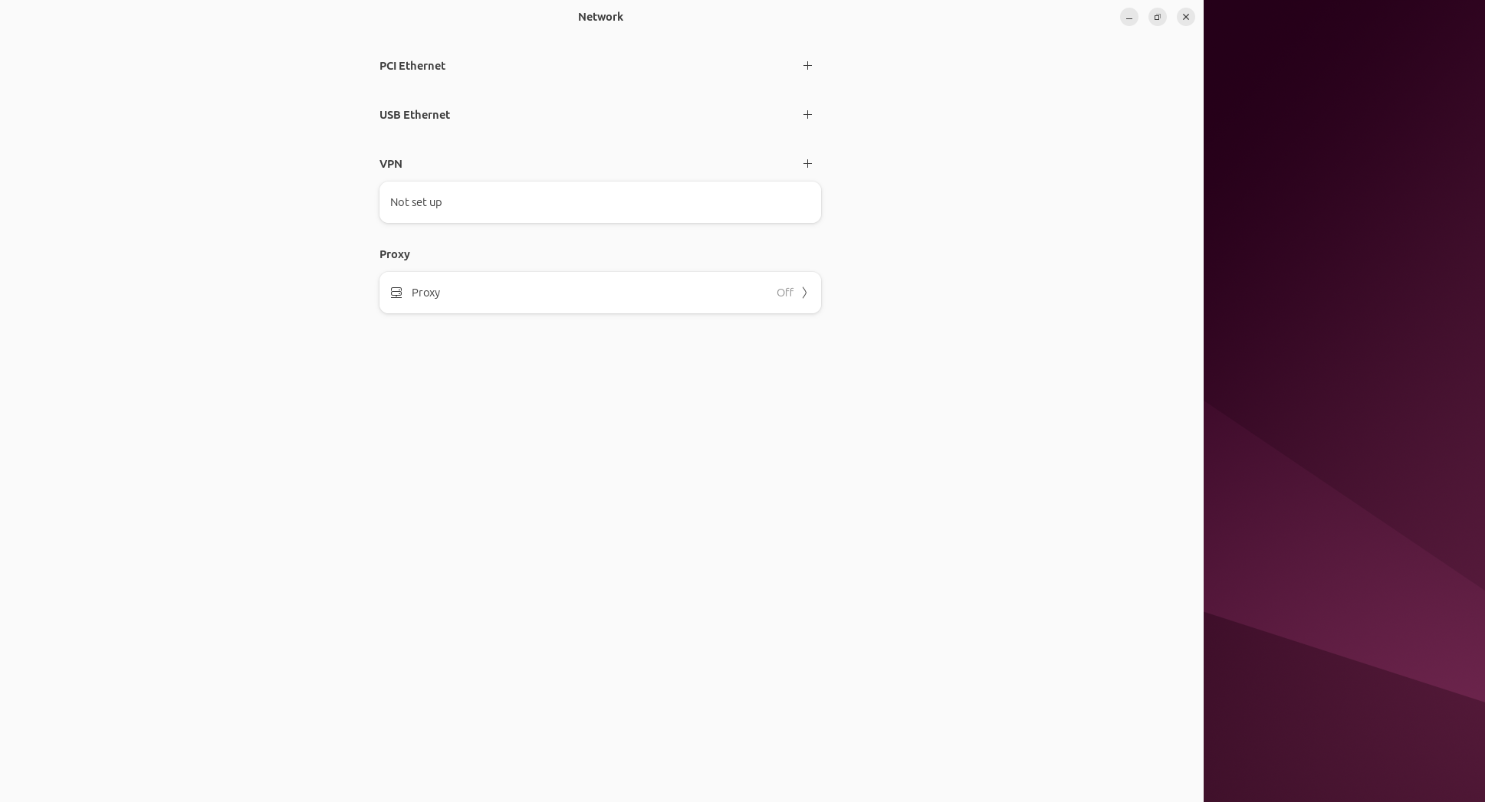
- Go to the network connection:
- Add PIC Ethernet/ add connection
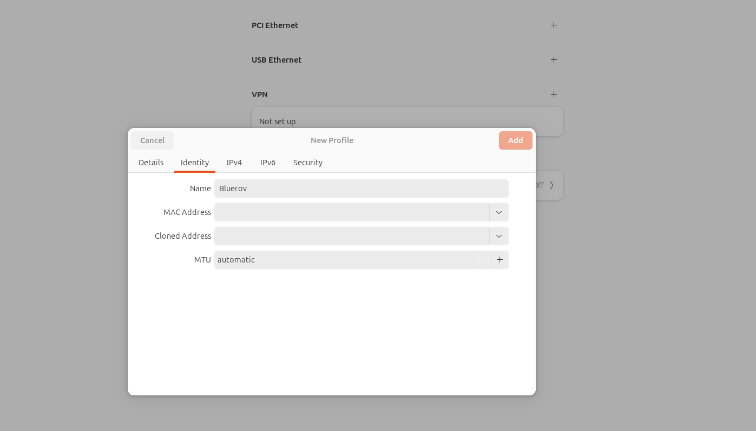
- Go to identity and give a name “BlueROV”
- Go to “IPV4”
- Select Manual

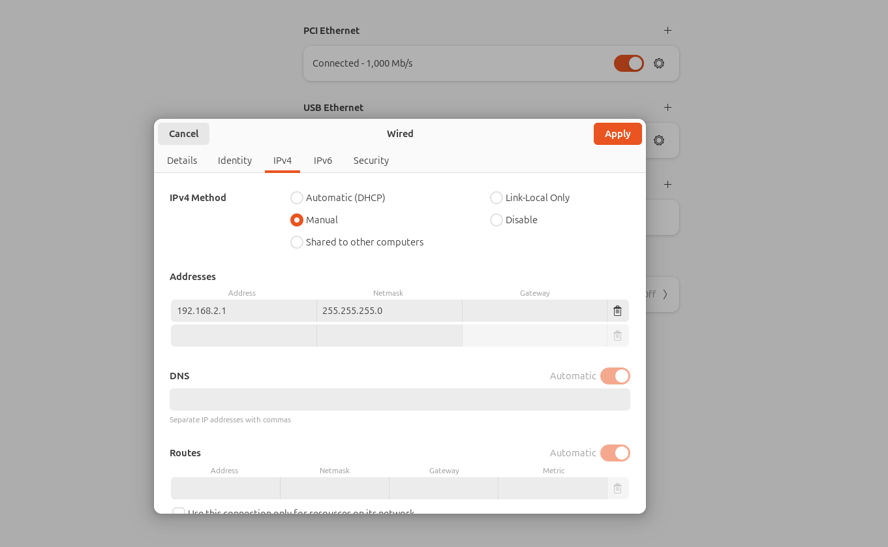
- In the address type: 192.168.2.1
- In netmask type: 255.255.255.0

Now go to BlueOS:
Open a browser and type:
192.168.2.2
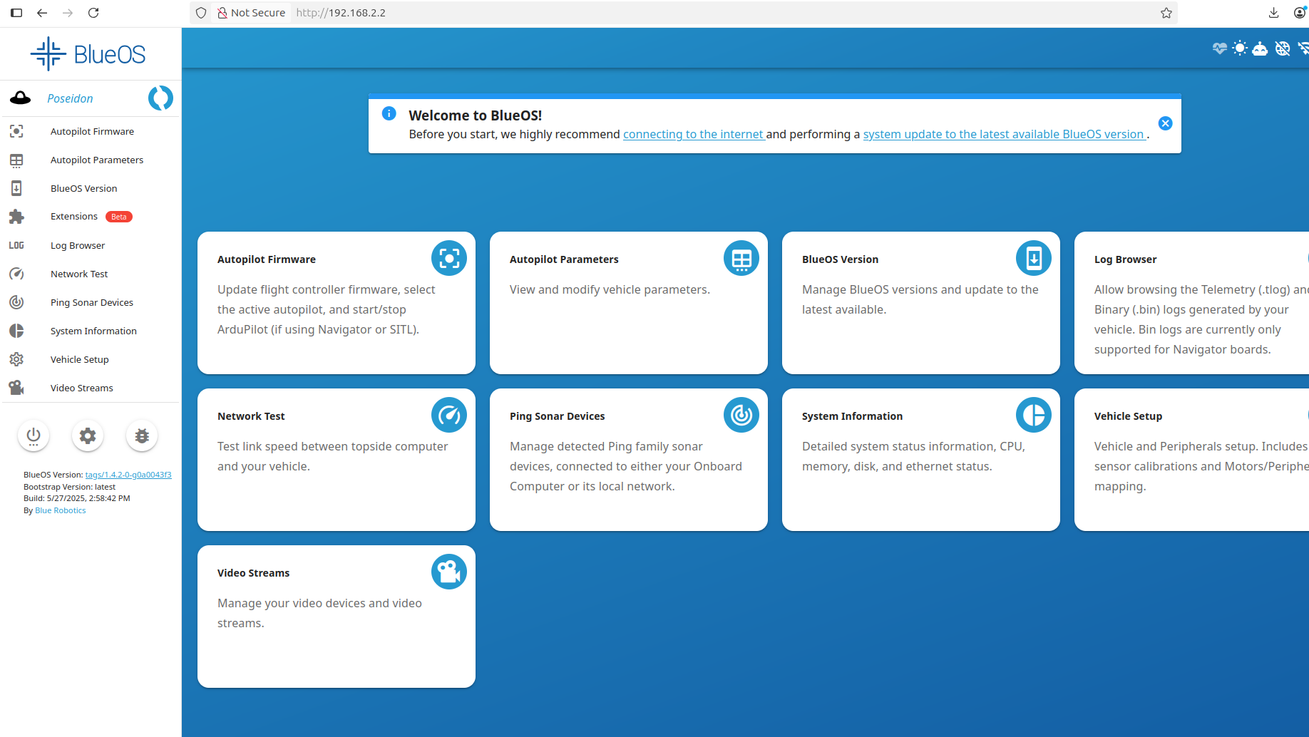

Go to Autopilot Parameters:
and search “SYSID_MYCGS” and set the value to “1”

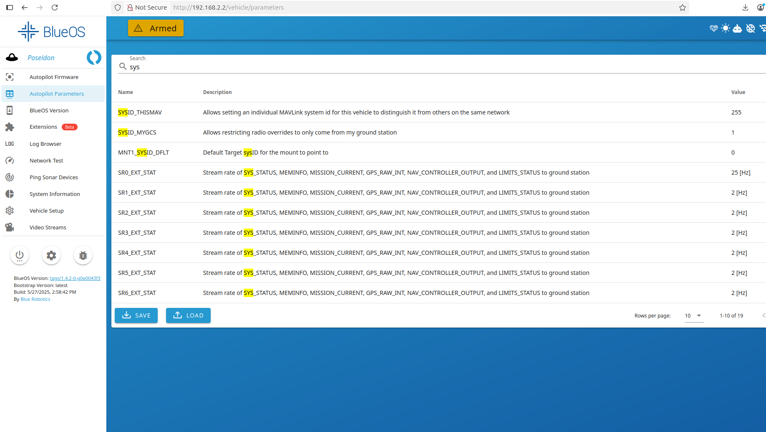

Now search “timeout” and set “FS_PILOT_TIMEOUT” to “-1” force it to this value.

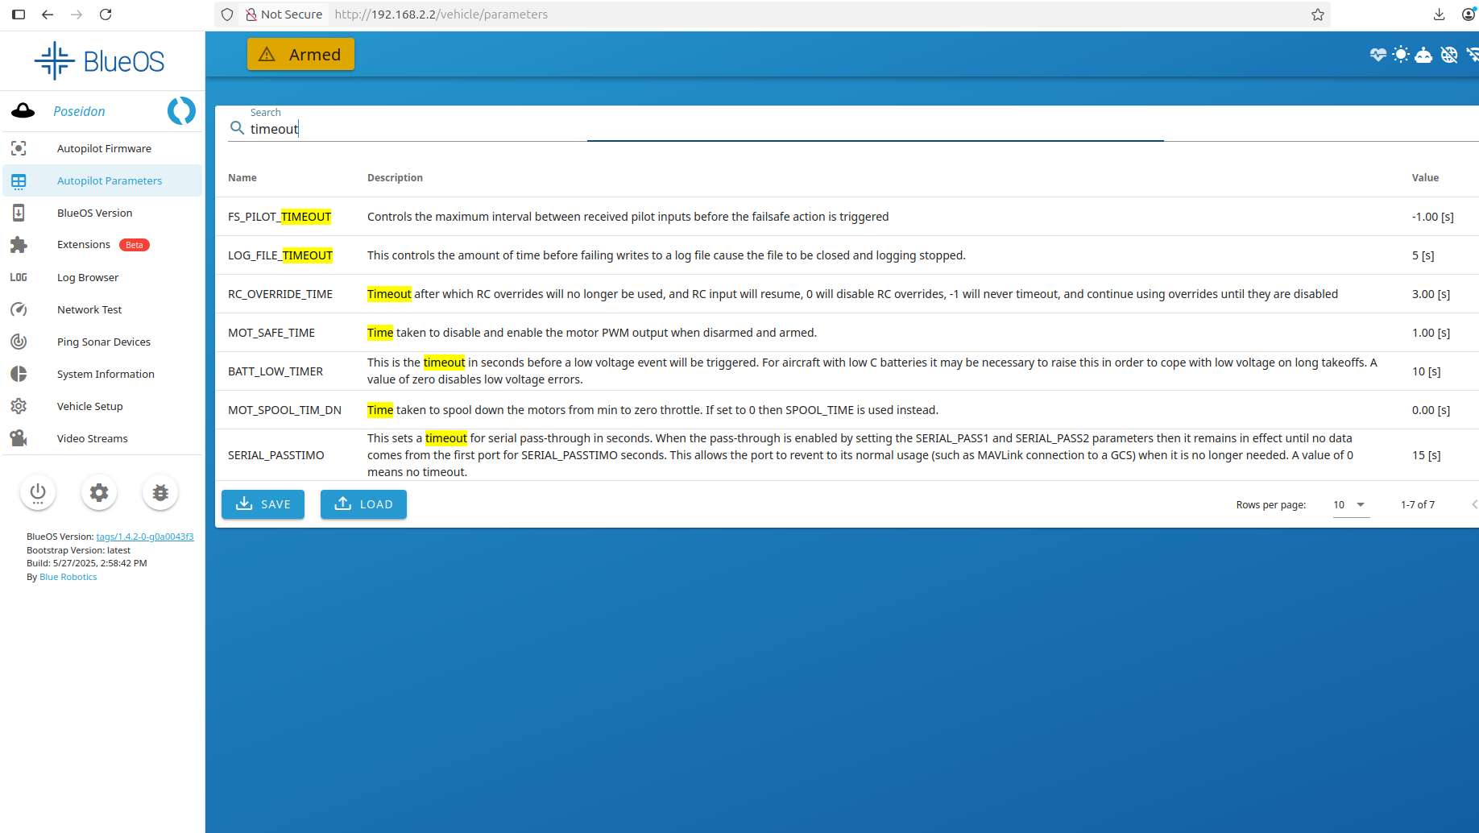

On your terminal (I use terminator) open 4 window and run the following command one by one

- ros2 launch autonomous_rov run_mavros.launch
- ros2 launch autonomous_rov run_listener.launch
- ros2 launch autonomous_rov run_gamepad.launch
- ros2 run autonomous_rov video
Bingo!!! you can now press start button on your gamepad and arm the vehicle and control it.

